**Students Profile-2022**

Yes

to

(Passport Size)

Photo

(Passport Size)

Photo

(Passport Size)

Photo

(Passport Size)

**Select 1 option only :** Placements Higher Studies Entrepreneurship Others (Specify)

(Passport Size)

Yes

oto

(Passport Size)

**Priority in Placements 1**: Salary 2. Choiced Profile (Specify)

**Please specify the reason of your choice** :- To obtain a responsible position in the Organization that best utilizes my skills and provides opportunities to grow my technical and managerial skills while fulfilling company goals.

**Name :** Divyanshu Sethi

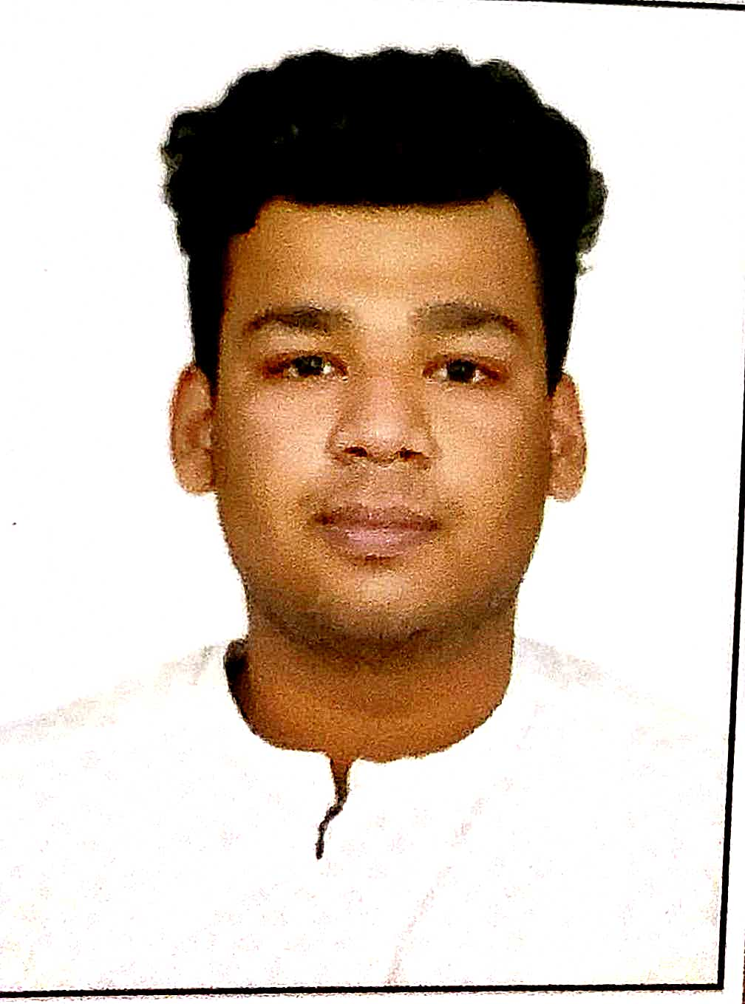

**S/o, D/o :** Mr. Satya Narayan & Mrs. Asha Narayan Sethi

**Father’s / Mother’s / Sibling Occupation :** Govt. Servant(Father)

**(Name of Company / Organization/ Family Business) :** Ministry of Railways

**Address :** 653, Sector – 9, R.K Puram, New Delhi

**City :** Delhi **Pin Code :** 110022

**Date of Birth (DD/MM/YY):** 30/01/01 **Branch/Shift:** CSE - Shift (Ist)

**U/Roll No :** 10915002719

**Tel.No. :** (**R**) *nil* (**M**) : 9650895690

**Email ID :** divyanshu2001.ds@gmail.com

**Gap in Academics (In years) : _**0_

**Academic Distinction & Result (Semester wise % ; without credits) :**

|  |  |  |  |
| --- | --- | --- | --- |
| 10th | 76.80 | Diploma(if any) : *nil* | |
| 12th | 74.69 |
| Sem. I | 63.923 | Sem. IV | 87.333 |
| Sem. II | 68.667 | Sem. V | 89.083 |
| Sem. III | 84.400 | Sem. VI | Result Awaited |

**Overall**  : 78.237 %

**Training/Projects @ :**

* Paid Internship at ***HPCL*** Data Center, Laxmi Nagar, Delhi (2 months)
* QR Code Scanner (Python)
* ***PepCoding*** – Currently Pursuing (6 months)
* Data Structure & Algorithm (Java)
* Web Development (React)

**Projects :**

1. **File-System-Organizer (using JAVA SCRIPT and node.js)**
2. If you have numerous Files in a folder and they are not Properly arranged
3. So you can use this tool to arrange them in specific directory according to their extension
4. **GitHub Web Scraper**

Using node.js

**Personality Profile * :**

I am an enthusiastic, self-motivated, reliable, responsible and flexible person. I am able to work well both in a team environment as well as using own initiative, I have good listening and communication skills, I prefer an active and dynamic approach in getting things done. Working well under pressure and adhere to strict deadlines is one of my forte. I identify and develop my opportunities.

**Extra Curricular Activities # :**

* Participated in Doubt solving Community of PepCoding
* Participated - Sec-1, RWA Sports day

**Desired Career Goals : (a) Short – Term :** To be capable enough to earn a great placement offer with a decent LPA or CPA for instance. Entering and surviving in Corporate World.

**(b) Long – Term :**

* Executive or Chief Level (IT Company)
* Preparing for Gate (PSUs)
* Govt. Sector

**Any Other Important Information :** *nil*

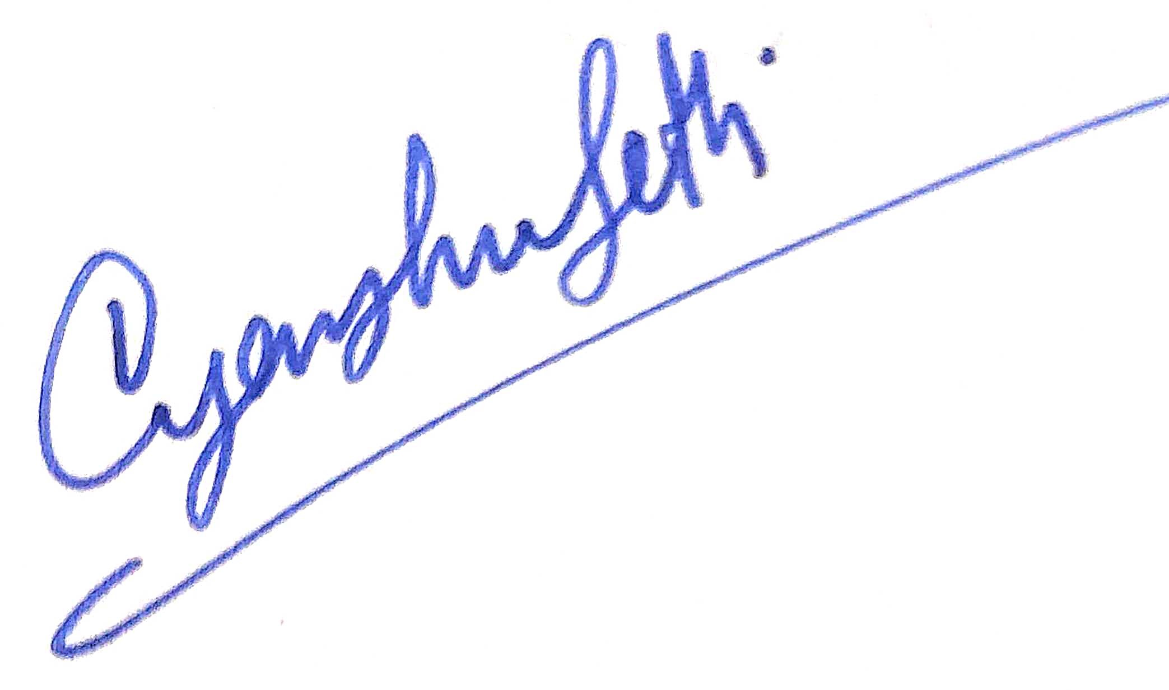



**Signature of Student**

**Signature Of Guardian**

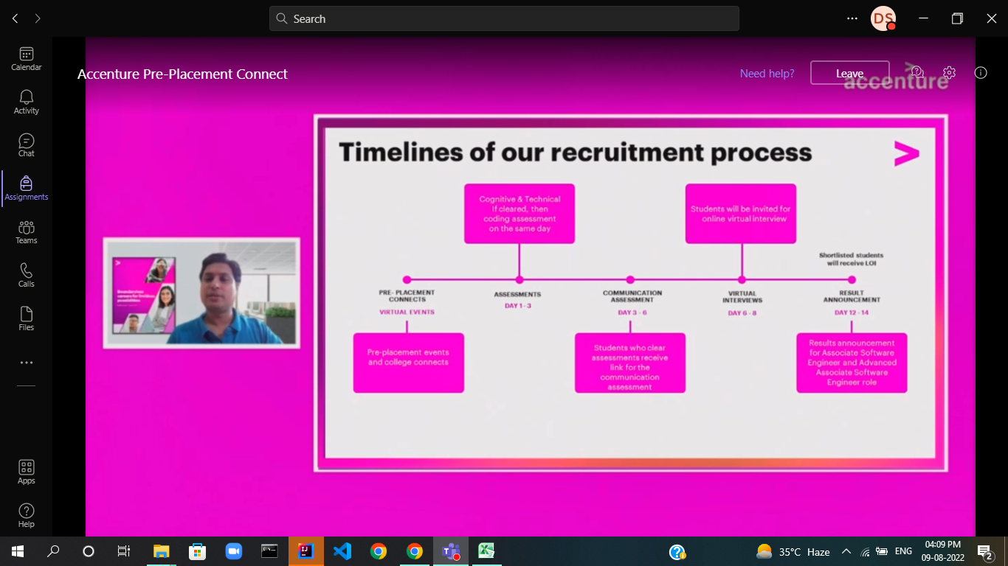

**GUIDELINES**

**NOTES : -**

**@** Also may mention about any SEMINARS, WORKSHOPS, CONFERENCES ATTENDED/INDUSTRIAL VISITS UNDERTAKEN

**\*** May describe in terms of :-

(i) Aptitude :- Indicate preference for a particular type of a functional activity e.g.…… planning / Manufacturing / Operations / Computer Software Development / Hardware Mgt. / Materials Mgt. etc.

(ii) Strengths :- Hardwork & Sincerity / sense of commitment & dedication / Honesty & Integrity / Adaptability to different setups / Innovative / Ability to work under pressure & deadlines / willingness to excel etc.

(iii) Weakness :- Over ambition / over enthusiasm / stickler for cleanliness / over eager to get result quickly / seeking perfection in every activity etc.

**#** Sports & Quiz / Tech Fest / Declamation etc.

